WEEK-6

**4. ReactJS-HOL**

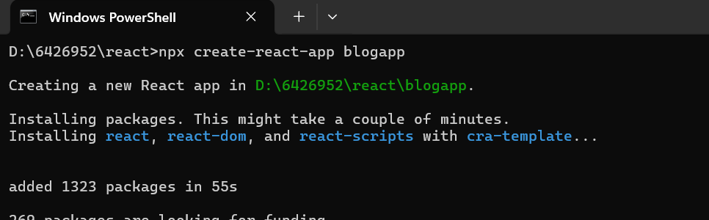

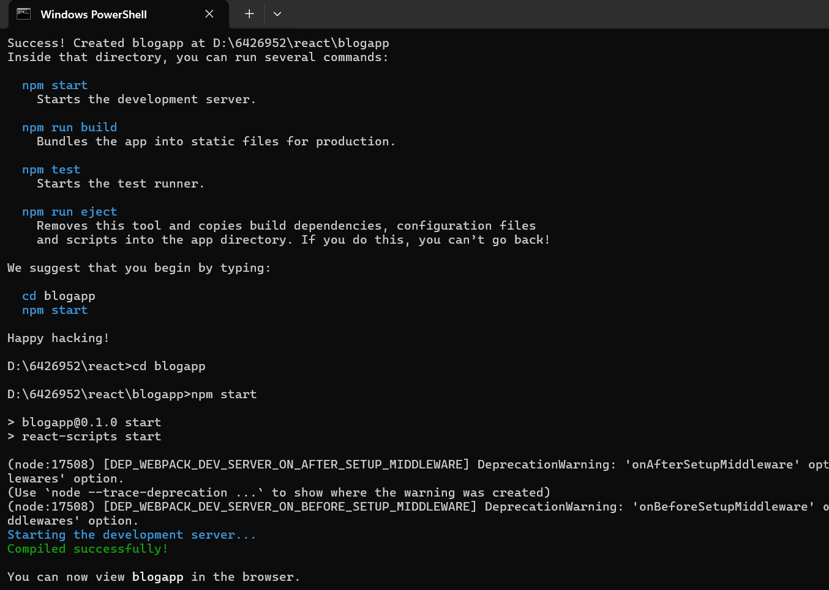

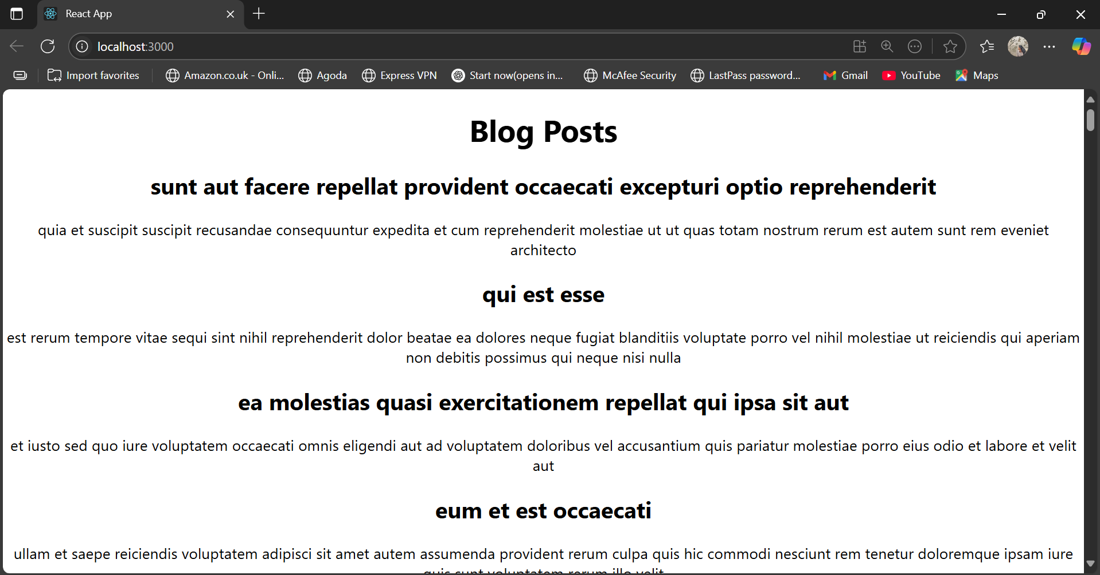

**App.js:**  
import React from 'react';

import './App.css';

import Posts from './Posts';

function App() {

  return (

    <div className="App">

      <Posts />

    </div>

  );

}

export default App;

**Post.js:**  
import React from 'react';

class Post extends React.Component {

  constructor(props) {

    super(props);

  }

  render() {

    const { title, body } = this.props;

    return (

      <div>

        <h2>{title}</h2>

        <p>{body}</p>

      </div>

    );

  }

}

export default Post;

**Posts.js:**  
import React from 'react';

import Post from './Post';

class Posts extends React.Component {

  constructor(props) {

    super(props);

    this.state = {

      posts: []

    };

  }

  loadPosts = () => {

    fetch('https://jsonplaceholder.typicode.com/posts')

      .then(response => response.json())

      .then(data => {

        this.setState({ posts: data });

      })

      .catch(error => {

        console.error('Error fetching posts:', error);

      });

  };

  componentDidMount() {

    this.loadPosts();

  }

  componentDidCatch(error, info) {

    alert("An error occurred: " + error);

  }

  render() {

    return (

      <div>

        <h1>Blog Posts</h1>

        {this.state.posts.map(post => (

          <Post key={post.id} title={post.title} body={post.body} />

        ))}

      </div>

    );

  }

}

export default Posts;